|  |  |  |  |  |  |  |
| --- | --- | --- | --- | --- | --- | --- |
| **Drawing No:** | | **Rev No:** | | | **Manhole/Catchpit:** | |
| **No** | Inspection Stage | **Inspection** | | | | |
| **N/A or √** | **Initials** | **Date** | **Comments** | |
| 1 | Setout |  |  |  |  | |
| 2 | Excavation |  |  |  |  | |
| 3 | Prepare & Level Base Bedding – Testing req? |  |  |  |  | |
| 4 | Confined Space Permit required? |  |  |  |  | |
| 5 | Installation of Precast Base Unit on Bedding |  |  |  |  | |
| 6 | Installation of Precast Risers to Lid Level |  |  |  |  | |
| 7 | Installation of Manhole/Catchpit Furniture, Steps / clamps |  |  |  |  | |
| 8 | Haunching / Make Good Base. Joints sealed |  |  |  |  | |
| 9 | Installation of Precast Lid |  |  |  |  | |
| 10 | Backfill Around Manhole/Catchpit – Tested |  |  |  |  | |
| 11 | Installation of Cast Iron Frame A Cover Lid Level – set with contour |  |  |  |  | |
| 12 | Final Inspection |  |  |  |  | |
| The above works have been inspected and are considered compliant with the drawings, specifications and instructions | | | | | | |
| Signed by…………………………….  Name: ………………………………. | | | Position:…………………………… | | | Date:……………… |

|  |  |
| --- | --- |
| Location/Chainage: | Size: |
| Class: |

|  |  |
| --- | --- |
| A. Dia: ___________________ | Invert: ___________________ |
| B. Dia: ___________________ | Invert: ___________________ |
| C. Dia: ___________________ | Invert: ___________________ |
| D. Dia: ___________________ | Invert: ___________________ |

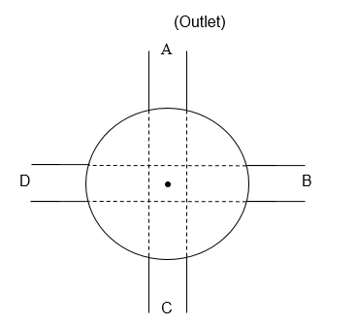

Concrete manhole lid opening

RL:

diameter: _______________mm

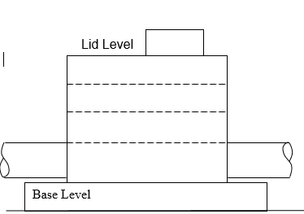

RL:

PHOTO of Benching in Manhole